Cable tray report

Cable tray name: A012

Cable tray type: Niedax KL 100.603 F

Cable tray purpose: Type A (Pink color) for MV cables

# Cable tray dimensions:

Height: 100 [mm], Width: 600 [mm], Length: 3000.00 [mm],

Weight: 4.738 [kg/m],

# Cables laying on the tray:

|  |  |  |  |  |
| --- | --- | --- | --- | --- |
| **No.** | **Cable name** | **Cable type** | **Cable diameter [mm]** | **Cable weight [kg/m]** |
| 1 | =H2=KF1=TAC1=WBB13 | N2XS(FL)H 12/20kV (24)kV 1x300/25mm² | 40.0 | 4.000 |
| 2 | =H2=KF1=TAC1=WBB14 | N2XS(FL)H 12/20kV (24)kV 1x300/25mm² | 40.0 | 4.000 |
| 3 | =H2=KF1=TAC1=WBB15 | N2XS(FL)H 12/20kV (24)kV 1x300/25mm² | 40.0 | 4.000 |
| 4 | =H2=KF1=TAC1=WBB16 | N2XS(FL)H 12/20kV (24)kV 1x300/25mm² | 40.0 | 4.000 |
| 5 | =H2=KF1=TAC1=WBB17 | N2XS(FL)H 12/20kV (24)kV 1x300/25mm² | 40.0 | 4.000 |
| 6 | =H2=KF1=TAC1=WBB18 | N2XS(FL)H 12/20kV (24)kV 1x300/25mm² | 40.0 | 4.000 |
| 7 | =H2=KF1=TAC1=WBB19 | N2XS(FL)H 12/20kV (24)kV 1x300/25mm² | 40.0 | 4.000 |
| 8 | =H2=KF1=TAC1=WBB20 | N2XS(FL)H 12/20kV (24)kV 1x300/25mm² | 40.0 | 4.000 |
| 9 | =H2=KF1=TAC1=WBB21 | N2XS(FL)H 12/20kV (24)kV 1x300/25mm² | 40.0 | 4.000 |
| 10 | =H2=KF1=TAC1=WBB22 | N2XS(FL)H 12/20kV (24)kV 1x300/25mm² | 40.0 | 4.000 |
| 11 | =H2=KF1=TAC1=WBB23 | N2XS(FL)H 12/20kV (24)kV 1x300/25mm² | 40.0 | 4.000 |
| 12 | =H2=KF1=TAC1=WBB24 | N2XS(FL)H 12/20kV (24)kV 1x300/25mm² | 40.0 | 4.000 |
| 13 | =H2=KF1=TAC1=WEB1 | RZ1-K GREEN/YELLOW 0.6/1 kV 1x185mm² | 23.1 | 1.740 |

# Weight calculations:

## Supports weight calculations:

The supports weight calculations depend on the distance between the supports based on the tray length and the count. For “KL 100.603 F” type the maximal distance between two supports is 1.5 meters. For trays that the length is less than 1.5 meters, we have 2 pieces of supports. For trays that the length is bigger than 20% from the base 1.5 meters, there is additional support.

Supports count: (3 * 1000) / 1.5 ≈ 3 = 3 [pcs.],

Weight per piece: 5.416 [kg]

The total weight of the supports is calculated by the count of the supports, multiplied by the weight per piece:

Supports total weight: 3 * 5.416 = 16.248 [kg]

The total weight per meter is calculated by division of the tray length and the total weight of the supports:

Supports weight load per meter: 16.248 / (3000 * 1000) = 5.416 [kg/m]

## Tray own weight calculations:

Tray weight load per meter is calculated by the sum of cable tray weight and support weight per meter:

Tray weight load per meter: 4.738 + 5.416 = 10.154 [kg/m]

Total tray weight is calculated by combining the own weight per meter with added supports weight per meter, then multiplied by the tray total length.

Tray total own weight: 10.154 * (3000 / 1000) = 30.462 [kg]

## Cables on tray weight calculations:

Cables weight load per meter is calculated by the sum of cables weight per meter:

Cables weight load per meter: 4 + 4 + 4 + 4 + 4 + 4 + 4 + 4 + 4 + 4 + 4 + 4 + 1.74 = 49.74 [kg/m]

Total weight of all the cables on the tray is the sum of the cables weights.

Total weight on the tray: 49.74 * (3000 / 1000) = 149.22 [kg]

## Total weight:

Total weight load per meter: 10.154 + 49.74 = 59.894 [kg/m]

Total weight: 30.462 + 149.22 = 179.682 [kg]

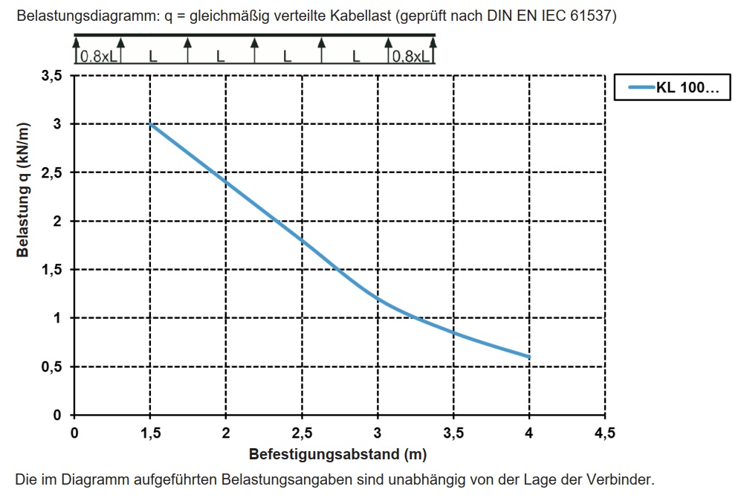

Picture 1. – Load per meters diagram regarding the distance between the supports.

# Free space calculations:

All trays “KL 100.603 F” type are ladder type trays. Rung spacing 300 [mm], with continuously perforated side rails, with riveted, upwardly open rungs made of C-profiles.

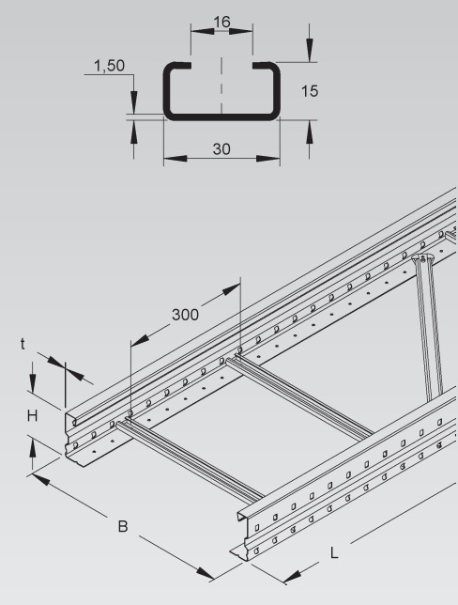

Picture 2. – Cable tray type overview.

Tray board height is 100 [mm], but the C-profiles occupy a part of the volume space. So, the useful height for the tray is 100 – 15 = 85 [mm]. Medium voltage cables are laid and grouped in a triangle (“trefoil”) formation, forming each a 3-phase system.

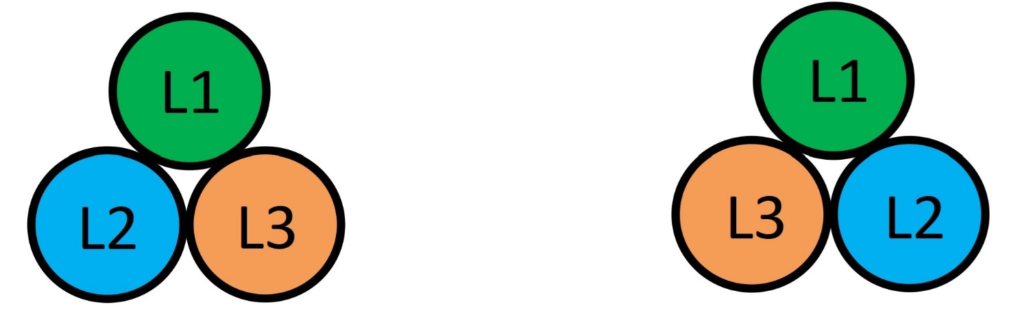

Picture 3. – Trefoil cables formation type overview.

The minimum distance of cable bundle/trefoil is 2x outer cable diameter (2d). Between parallel laid power cables minimum distances have to be complied with along the entire laying distance (except for building-pass-through / penetrations). Power cables laid in parallel shall have the same cable lengths. A maximum cable length difference of 3% can be accepted if properly considered in cable dimensioning (de-rating). No free space is considered.

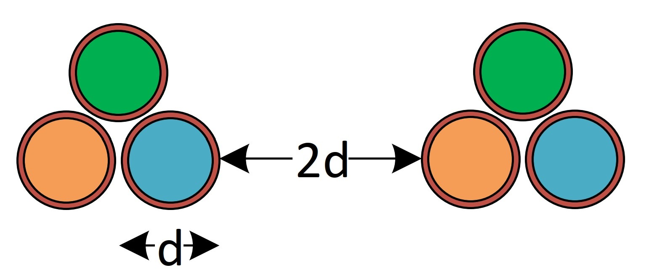

Picture 4. – Minimum distance of cable trefoil.

